SET-2
Q1. Using AI, create a database schema for a Student Attendance Management System.
- Generate CREATE TABLE queries for Students, Courses, and Attendance with random data that can full fill below task
- Write a query to find students with attendance below 75%.
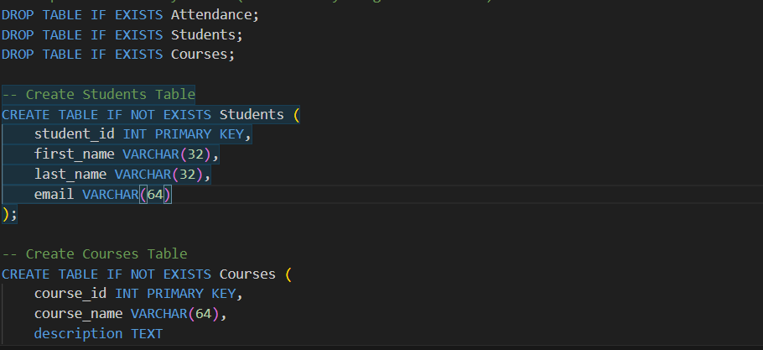
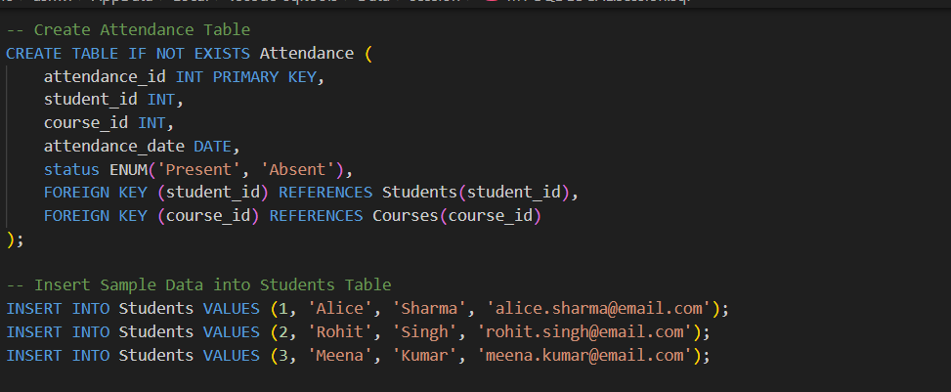
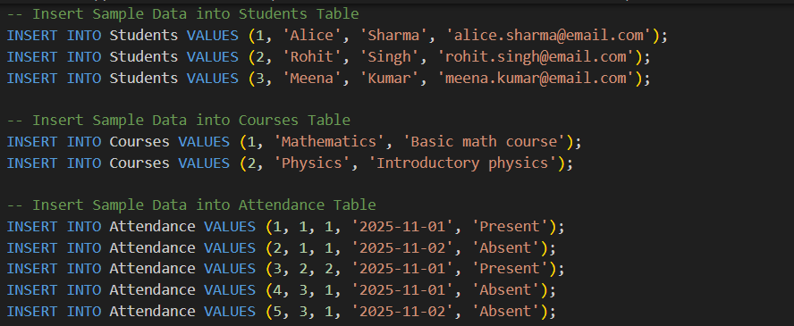
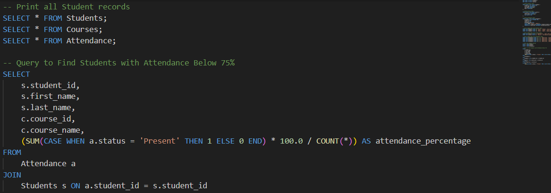
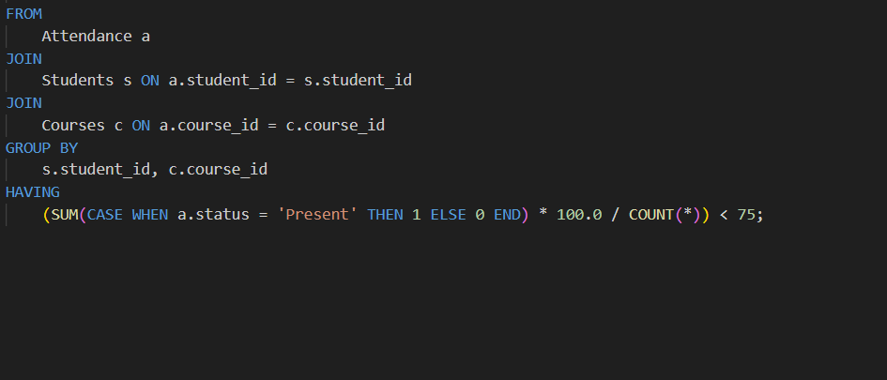
OUTPUT:
TABLES OUTPUT:
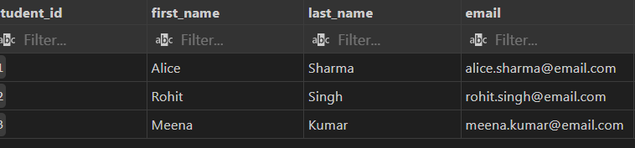
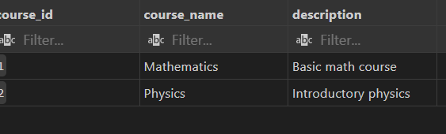
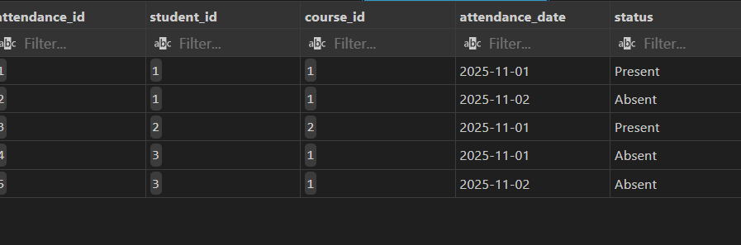QUERY OUTPUT:
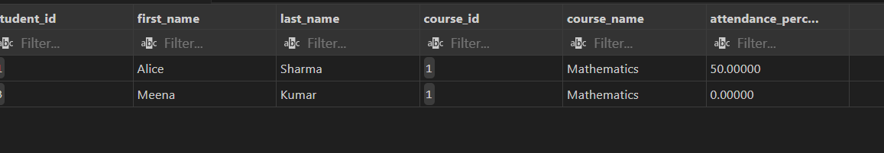
Q2. Generate a Python data preprocessing script using AI to:
- Generate dataset using ChatGPT that helps to complete the below two tasks
- Fill missing values with column mean.
- Encode categorical data using one-hot encoding.
- Save the cleaned dataset as processed_students.csv.
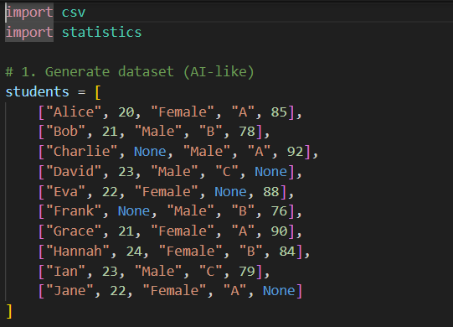
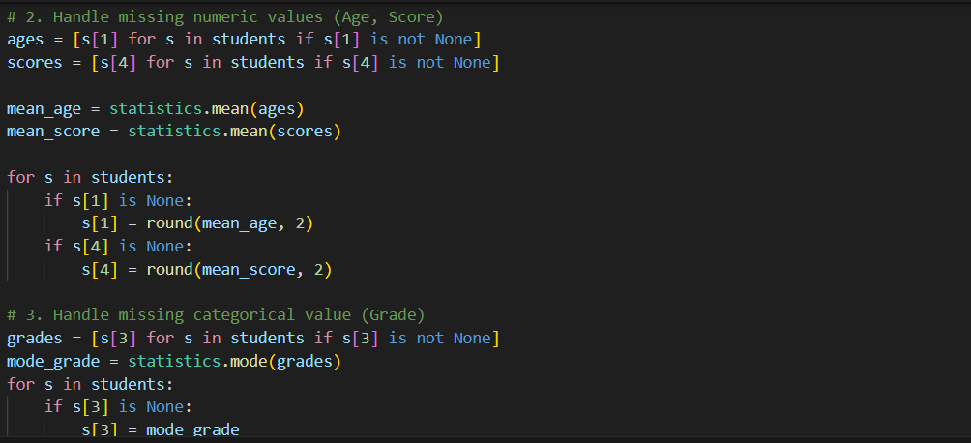
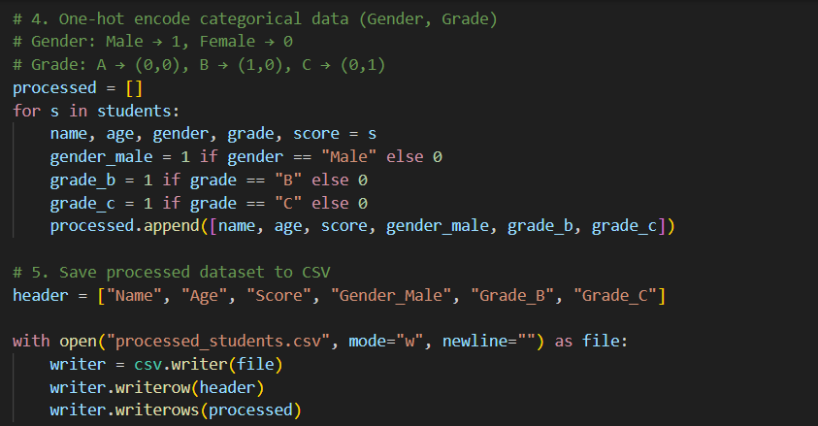
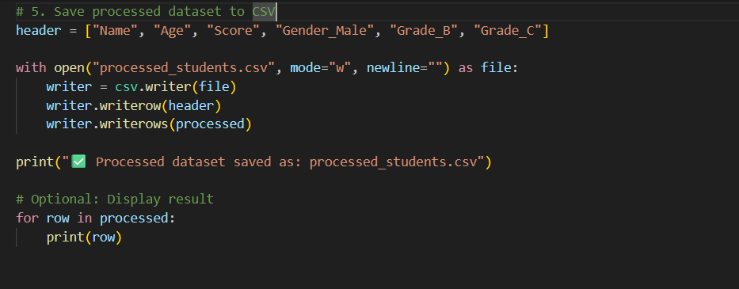
OUTPUT:
